StudyMind Elite
Multi-Agent AI Academic Coach
Milestone II | Multi-Agent Workflow Design Document | AGENTIC AI Section 003 | Spring 2026
Student | Abenezer Bekele
Course | AGENTIC AI Section 003 Spring 2026
Milestone | Milestone II Multi-Agent Workflow 5 percent of final grade
Live App | opal.google/app/1goGNCROe2AuCkEVwFu7gDV47ss3QIPQe
Published | March 26 2026
Agents | 7 specialized agents across 4 functional layers
Pattern | Fixed pipeline with generate-critique-revise loop and stopping condition at 3 cycles

1. System Overview
StudyMind Elite is a fully implemented 7-agent AI study planning system built on Google Opal with Gemini 1.5 Flash. A student uploads one syllabus PDF and the system automatically extracts all deadlines and builds a prioritized 7-day study schedule and runs a self-correcting quality review and renders an interactive calendar dashboard. The student does not type a single deadline manually.

Multi-agent pattern used: Fixed sequential pipeline from Ingestion Agent through Interface Agent with an inner generate-critique-revise loop between the Critic Agent and Rewriter Agent. The loop runs a maximum of 3 cycles as the stopping condition before passing the best available schedule to the Interface Agent regardless of remaining issues.

2. Working Implementation Screenshots

Screenshot 1 — Live Dashboard Output
The following screenshot shows the fully working StudyMind Elite dashboard running at the live Opal link. The system successfully extracted all deadlines from the BUSA 4980 syllabus and generated a complete 7-day study schedule with spaced repetition sessions. The deadline urgency panel correctly flags BSG Strategy Journal Entry 3 as Critical with 1 day remaining. All Done buttons and session type labels are functional.

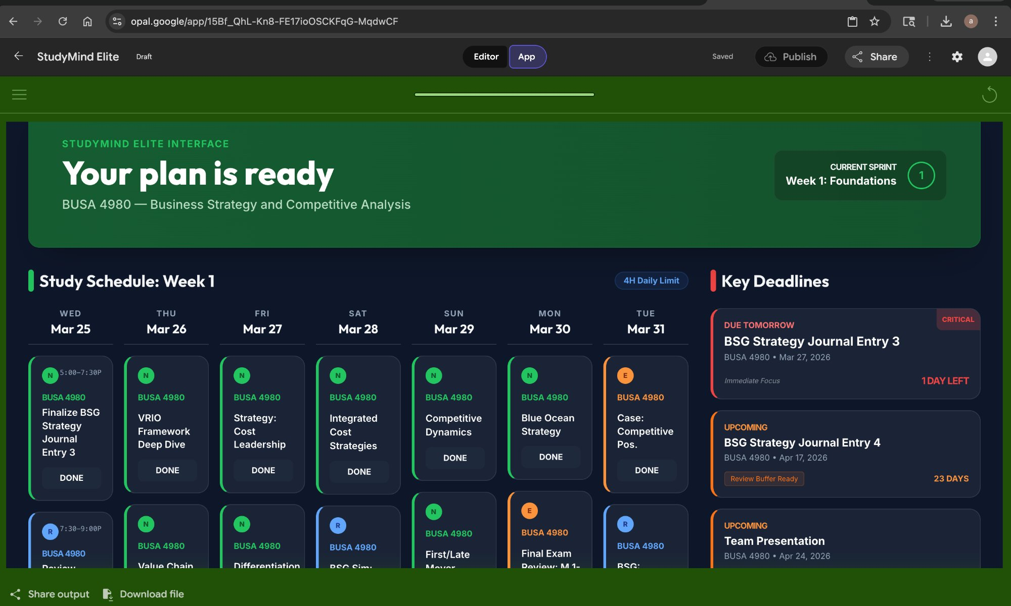
Figure 1 — Live StudyMind Elite dashboard at opal.google/app/1goGNCROe2AuCkEVwFu7gDV47ss3QIPQe

Screenshot 2 — 9-Step Agent Pipeline in Opal Editor
The Opal editor view shows the complete 9-step agent pipeline. Each node contains a detailed agent-specific prompt implementing the architecture described in this document. The pipeline runs left to right from syllabus upload through the final calendar dashboard output.

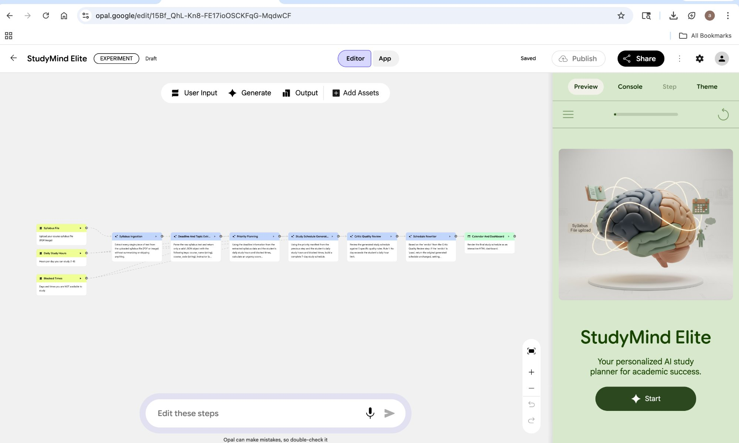
Figure 2 — Opal editor showing all 9 configured agent steps

3. Agent Architecture
The system implements 7 specialized agents organized into 4 functional layers. Each agent has a distinct role with a defined input format and a structured JSON output that feeds the next agent in the pipeline.

Layer | Agent | Role | Tools and Output
Input | Ingestion Agent | Extracts full raw text from uploaded PDF without summarizing | Gemini document understanding outputs raw text string
Input | Extraction Agent | Parses raw text into structured JSON with deadlines and grade weights | Gemini structured output produces deadline JSON with confidence scores
Intelligence | Planner Agent | Scores each assignment by urgency and classifies as Critical or Important or Scheduled | Priority formula outputs planning manifest JSON
Intelligence | Content Agent | Generates topic summaries and flashcard questions for each study subject | Gemini generation outputs content blocks per topic
Intelligence | Scheduler Agent | Builds 7-day schedule using spaced repetition and respects blocked times | SM-2 algorithm outputs schedule JSON version 1
Quality Control | Critic Agent | Reviews schedule against 5 hard rules and returns verdict with specific issues | Rules engine outputs verdict JSON with suggested fixes
Quality Control | Rewriter Agent | Applies Critic fixes and logs all changes then returns corrected schedule | Diff logic outputs revised schedule JSON version 2
Output | Interface Agent | Renders interactive calendar and deadline heatmap and progress rings | HTML renderer outputs live student dashboard

4. Agent Communication and Data Flow
All agents communicate through structured JSON passed as step output in the Opal workflow. Each agent reads the output of the previous step and produces its own structured output. The table below shows every data handoff in the pipeline.

From agent | To agent | Data passed | Format
Ingestion Agent | Extraction Agent | Full raw syllabus text | Plain text string
Extraction Agent | Planner Agent | All deadlines and exams and grade weights | JSON with deadline and exam arrays
Input Agent | Planner Agent | Daily study hours and blocked time windows | Two text strings merged into planner context
Planner Agent | Scheduler Agent | Priority queue and daily minute targets | Planning manifest JSON
Scheduler Agent | Critic Agent | 7-day schedule with all sessions | Schedule JSON version 1
Critic Agent | Rewriter Agent | Verdict and issues and fix suggestions | Verdict JSON
Rewriter Agent | Critic Agent loop | Revised schedule for re-review up to 3 cycles | Schedule JSON version 2
Rewriter Agent | Interface Agent | Final validated schedule | Schedule JSON final version

Loop stopping condition: The Rewriter Agent checks a cycle_count field embedded in the JSON payload. If cycle_count is below 3 and the verdict is needs-revision the loop continues. If cycle_count reaches 3 or the verdict is pass the pipeline exits to the Interface Agent. Unresolved issues are shown as orange warning flags on the dashboard rather than blocking output.

5. Failure and Low Quality Output Handling

Data extraction failures
- If a date has confidence below 0.7 the Extraction Agent appends a question mark to the assignment name and displays it for student verification before planning begins.
- If the uploaded file produces no readable text the Ingestion Agent halts the pipeline and asks the student to upload a clearer file.
- If fewer than 2 deadlines are found the system warns the student that the syllabus may be incomplete and offers to proceed with partial data.

Scheduling failures
- If total study demand exceeds available hours the Planner Agent sets overload_warning to true and the Scheduler reduces lower-priority sessions while protecting Critical tier assignments.
- If a deadline cannot be covered with 2 days of buffer the Scheduler adds a coverage_gap flag so the Critic can detect and the Rewriter can attempt to resolve it.

Critic loop failures
- The loop has a hard maximum of 3 revision cycles to prevent infinite loops when fixes create new violations.
- After 3 cycles the Interface Agent renders the schedule with unresolved issues highlighted in orange. The student sees exactly which rules still have issues rather than seeing a blocked or empty output.
- If the Critic Agent cannot evaluate a rule due to missing data the rule is marked as skipped rather than failed so it does not trigger unnecessary rewrites.

6. Milestone II Deliverables Checklist
Architecture diagram | Submitted as separate high-resolution PNG showing all agents and tools and data flow and feedback loop
Design document | This document covering agent roles and input and output formats and coordination mechanism and failure handling
Live implementation | opal.google/app/1goGNCROe2AuCkEVwFu7gDV47ss3QIPQe — fully working and published
Agent count | 7 distinct agents with different roles exceeding the minimum requirement of 2
Distinct agent roles | Planner and Executor and Critic and Verifier and Explainer roles all present
Coordination pattern | Fixed pipeline with inner generate-critique-revise loop and cycle limit stopping condition
Working screenshot | Figure 1 above shows the live dashboard processing a real GSU BUSA 4980 syllabus

StudyMind Elite | AGENTIC AI Section 003 | Spring 2026 | Milestone II

